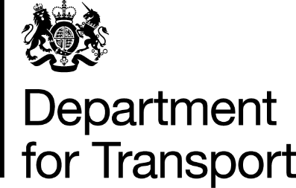

Follow-up form to be sent to Department for Transport no later than one week after the end of the relaxations (by 15 August 2021).

Please fill out all the fields below and send your completed form by email to RSSSFOLRCOVID19@dft.gov.uk

Name of operator

Operator Licence Number(s)

Name of responsible transport manager(s)

How many drivers used the relaxations?

What period were the relaxations used
from and until?

Were increased daily driving limits used?

Were the alternative pattern of weekly rest periods and the increased fortnightly driving limit used?

What type of loads were carried?

Failure to comply with the above, would be an indication to enforcement authorities that
the relaxations may have been used inappropriately and follow-up investigatory action
could occur.

